NAME:…………………………………………………………….. ADM NO……………….
SCHOOL……………………………………………………………………………………….
DATE………………………………………………….

END OF TERM ONE 2025 EXAMINATIONS
CHEMISTRY PAPER TWO MARKING SCHEME
233/2
INSTRUCTIONS TO CANDIDATES
- Write your name and index number in the spaces provided above
- Sign and write the date of examination in the spaces provided above
- Answer all the questions in the spaces provided
- Mathematical tables and silent electronic calculators may be used.
- All working must be clearly shown where necessary
- Candidates should check the question paper to ascertain that all the pages are printed as indicated and that no questions are missing
- Candidates should answer the questions in English. This paper has 12 printed pages.

FOR EXAMINERS USE ONLY:
Question | Maximum Score | Candidate’s Score
1 | 11
2 | 10
3 | 12
4 | 12
5 | 12
6 | 14
7 | 9
Total score

- Crystals of copper (ii) nitrate can be prepared by reacting solid copper (ii) oxide with dilute nitric (v) acid.
- Write a chemical equation for this reaction. (1mk)

CUO_{(s)} + 2HNO_{3(aq)} CU(NO₃)_{(aq)} + H₂O_{(l)}√
`
(b).A student is given a sample of copper (ii) oxide containing small amounts of insoluble impurities.
The passage is from her notebook and describes the method she uses to prepare some pure, dry crystals of copper (ii) nitrate from her sample of copper (ii) oxide.
Stage 1: place 50cm³ of dilute nitric (v) acid into a beaker and warm.
Stage 2: add the impure copper (ii) oxide a little at a time and stir, until it is in excess.
Stage 3: filter the mixture
Stage 4: heat the filtrate until the crystallization point is reached
Stage 5: allow the filtrate to cool
Stage 6: filter off the crystals and dry within filter paper.
- Why is the acid warmed in stage 1? (1mk)
To increase the Kinetic energy of the particles increasing the rate of a reaction (Accept: To speed up the reaction). ₎√ 1

- How will the student know when the copper (ii) oxide is in excess in stage 2. (1mk)
When some CUO remain undissolved at the bottom of the beaker /When no more can dissolve. ₎√ 1

- How will the student know when the crystallization point is reached in stage 4 (1mk)
Dip a glass rod in the solution and observe it in the air if there are crystals. √ 1

- In which stage are the insoluble impurities removed? (1mk)
Stage 3₎√ 1

(c) Substance X was known to be sodium iodide, potassium iodide or potassium bromide. state how a flame test could be used to decide whether substance X is a sodium or potassium compound. (2mks)
Burn √1 the two substances separately, the potassium salt burns with a lilac flame while sodium burns with a yellow flame. √1

(d) Study the table below and answer the questions that follow
process | observation
Copper metal was warmed with conc H₂SO₄ | A gas V with a chocking smell is produced.The gas changed the acidified potassium dichromate (vi)from orange to green .a blue solution is formed.
To a little of the blue solution excess aqueous ammonia was added | A light blue precipitate formed which dissolved to give a deep blue solution.

(i) Name gas V (1mk)
Sulphur (IV) Oxide√1

(ii) What property of gas V is indicated by the change in the acidified dichromate solution? (1mk)
It’s a reducing agent
(iii) Write the formula of the ion in the deep blue solution and name it (2mks)
Formula of the ion CU(NH₃)₄ ²⁺
Name of the ion Tetramine Copper (II) ions√1

2. Crude oil is a source of many compounds that contain carbon and hydrogen only.
(i) Name the process used to separate components of crude oil (1mk)
Fractional distillation

(ii). On what physical property does separation of the above components depend on.(1mk)
Boiling point
(b) Describe two simple chemical tests that be used to distinguish between C₂H₄ and C₂H₆. (4mks)
- In two separate beakers containing ethene and ethane add bromine water, √
the yellow bromine water changes to colourless in ethene but retained in ethane. √

- Add H⁺/KMnO₄ to both, √ in ethane the purple H⁺/KMNO₄ changes to colourless but in ethane the purple colour is retained. √

- Burn the 2 substances separately, √ ethane burns with a blue non-sooty flame while ethene burns with a yellow sooty flame. √

(c) The set up below was used to prepare and collect ethene gas. study it and answer the question that follow.
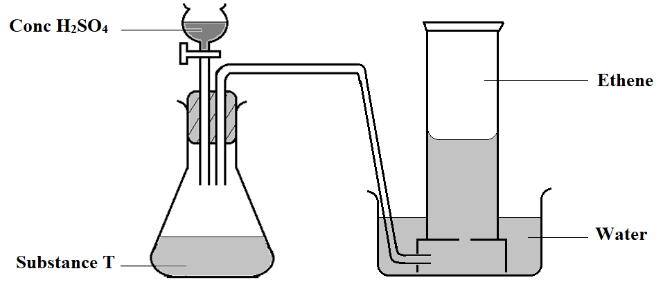
(i) Name the substance T (1mk.)
Ethanol √
(ii) Give the property of ethene that allows it to be collected as shown in the set up above. (1mk)
Its slightly soluble in water /Insoluble in water√
(d) One of the reaction undergone by ethene is addition polymerization. Give the name of the polymer and one disadvantage of the polymer it forms. (2mks)
Name: Polyethene√

Disadvantage of the polymer Non-biodegradable hence causes environmental pollution√

3.The flow chart below shows some of the processes involved in large scale production of sulphuric (vi) acid. Use it to answer the questions that follow.
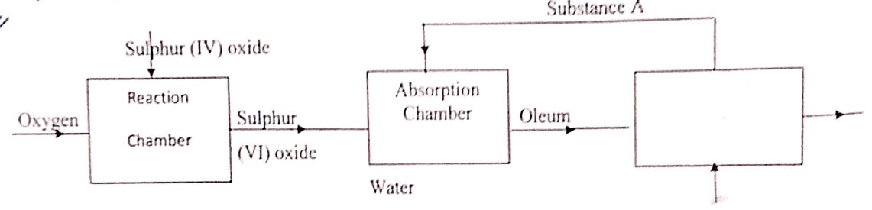

Water
(a).State the name of the industrial process described above. (1mk)
Contact process√

(b). Name substance A (1mk)
Concentrated sulphuric(VI) acid√

(ii).Write an equation for the process that takes place in the absorption chamber (1mk)
SO_{3(g)} + H₂SO_{4(s)} → H₂S₂O_{7(l)} √

(c). Vanadium (v) oxide is commonly used catalyst in the contact process.name another catalyst which can be used in this process. (1mk)
Platinum₎√

(d). Give two reasons why vanadium (v) oxide is commonly used catalyst (2mks)
- It is not easily poisoned by impuritie√

- It is cheaper√

(e).State and explain the observation made when concentrated sulphuric (vi) acid is added to crystals of copper (ii) sulphate in the beaker. (2mks)
Copper(II) sulphate crystals changes from blue to white, √
conc. H₂SO₄ is a dehydrating agent.√

(f).List the three optimum conditions for the production of sulphuric (vi) acid in the above named process. (3mks)
- Temperature of 450ºC√

- Pressure of 2 – 3 atmospheres√

(g). List any two uses of sulphuric (vi) acid. (2mks)
- Manufacture of sulphate fertilizers Any two @ 1mk
- Manufacture of detergents
- Manufacture of plastics
- Manufacture of dyes and paints
4. a) During the manufacture of hydrochloric acid, 50dm³ of hydrogen gas was burnt in 80dm³ chlorine.
(i) Write a chemical equation for the reaction between hydrogen and chlorine.(1mk)
H_{2(g)}+Cl_{2(g)} → 2HCl_{(g)} √

(ii) Which gas was in excess and by how much? (2mks)
Cl₂ , ₎√
by 80 – 50 =30dm³√

iii) What is the source of hydrogen used during the manufacture? (1mk)
cracking of long chain alkanes , from natural gas, electrolysis of brine Any 1mk
(iv) A solution of hydrogen chloride gas in water turns blue litmus red while a solution of hydrogen chloride gas in methyl benzene has no effect. Explain (2mks)
HCl in water ionizes releasing √
H⁺ that turns the litmus paper but HCl in methyl benzene remains in its molecular state √without ionizing.
(b) The set up below was used to prepare and study the reaction of chlorine gas. Study it and answer the questions that follow,
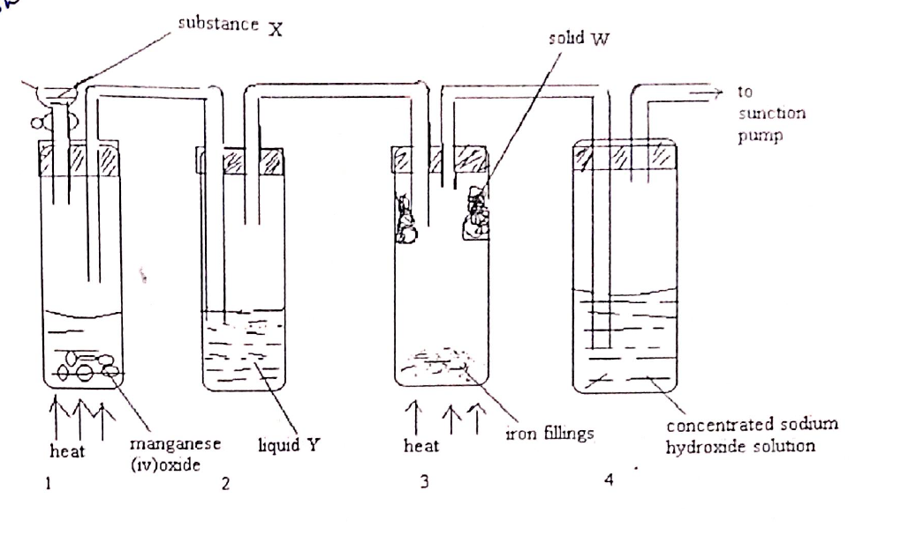
(i) Give the role of manganese (iv) oxide in the first boiling tube. (1mk)
To Oxidize hydrochloric acid to chlorine gas√1

(ii) Identify substances X and Y (2mks)
X: Concentrated HCl√1

Y: Concentrated H₂SO₄√1

(iii) Write a chemical equation for the reaction in boiling tube 3. (1mk)
2Fe_{(s)} +3CL_{2(g)} 2FeCl_{3(s)} √1

(iv) Explain why solid W is collected as shown in the set up. (1mk)
It sublimes when heated√1

(v) Name the other reagent that can be used instead of manganese (iv) oxide (1mk)
Potassium manganate VII, K₂Cr₂O₇, PbO₂ any 1mk
5.a) State two factors that should be considered when choosing fuel for cooking (2mks)
- Heating value any 1mk
- Environmental effects
- Cost
- Ease of storage

b) Define the term molar heat of combustion (1mk)
It’s the heat evolved when one mole of a substance is completely burnt in oxygen√1

c) The diagram below represents a set up that was used to determine the molar heat of combustion of butanol. 250cm³ of water was heated from 225K to 295K.the mass of butanol and lamp initially was 154.4g and dropped to 124.8g after the experiment.
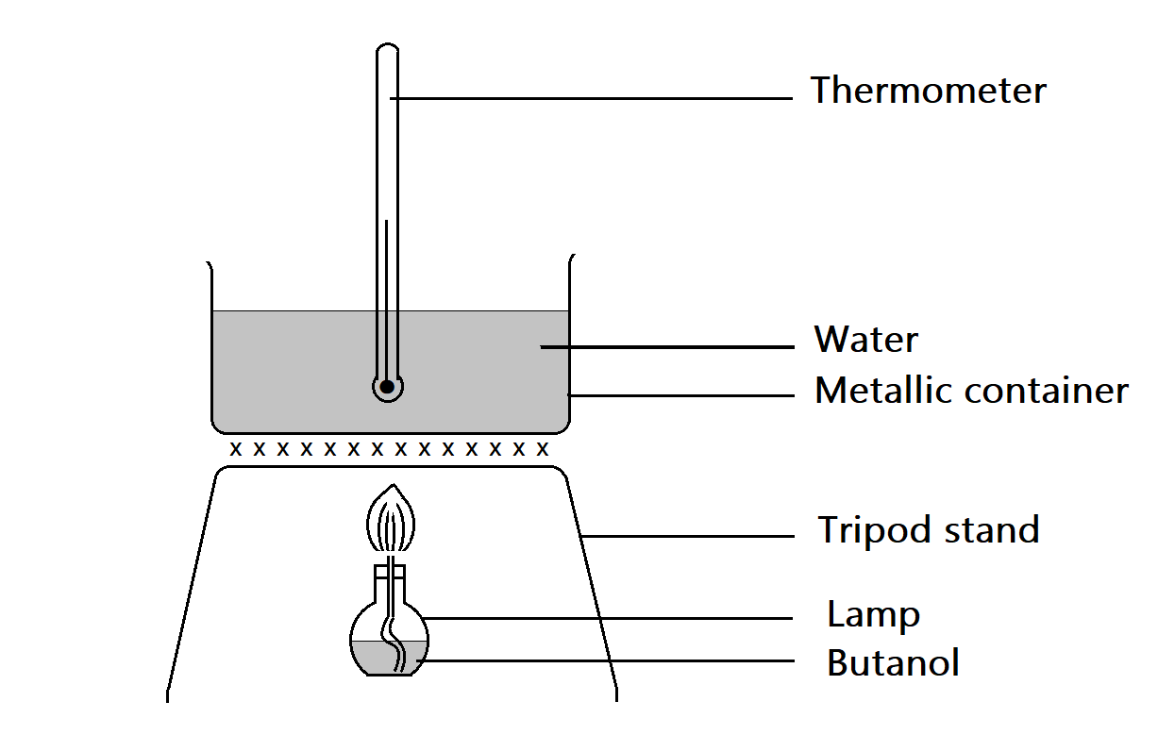
Calculate the;
(i) The mass of butanol burnt (1mk)
154.4 -124.8=29.6g√1

(ii) The heat change that occurred during the process (specific heat capacity of water=4.2Jg⁻¹K⁻¹,density of water 1g/cm³,C=12,H=1,0=16) (1½mks)
∆H = MCDT
250 X 4.2J⁻¹k⁻¹x (295-225)K√1

73500J // 73.5kJ√1

(iii) The molar heat of combustion of butanol(C₄H₉OH) (2mks)
Moles of Butanol = $\frac{29.6}{74} =0.4 moles$√1

$\frac{73.5}{0.4}= -183.75 kJ/mol$ √1

NB; NO UNITS penalize half a mark ,missing negative sign penalize ½

(iv) Heating value of butanol (1mk)
$\frac{183.75}{74}=2.4831kJ/g$√1

(d) Using the information below, determine the heat of combustion of butanol. (3mks)
H_{2(g)}+¹/20_{2(g)} H₂O_{(l)} ΔH₁= -286kJ/mol
C_{(s)} +O_{2(g)} CO_{2(g)} ΔH₂ = -394kJ/mol
4C_{(s)} +5H₂+_{1/2}O₂ C₄H9OH_{(l)} ΔH₃ = -597kJ/mol

ΔH₃
4C_{(s)} +5H₂+_{1/2}O₂ C₄H9OH_{(l)} ΔH₃ = -597kJ/mol

4O₂ ⁵_{/2}O₂ O₂
ΔH₁ ΔH₂

4CO_{2(g) +} 5H₂O_{(l)}

ΔH₃ = ΔH₁ - ΔH₂
-597 = 4(-394) + 5(-286) - ΔH₂
-ΔH₂ = 2409
ΔH₂ = 2409 kJmol⁻¹

6.a) The diagram below represents an incomplete set up of apparatus used to prepare and collect a dry sample of carbon (iv) oxide.
(i) Complete the diagram to show how a dry sample of carbon (iv) oxide was collected (3mks).
Drying agent (1mk)
Method of collection (1mk)
Workability (1mk)
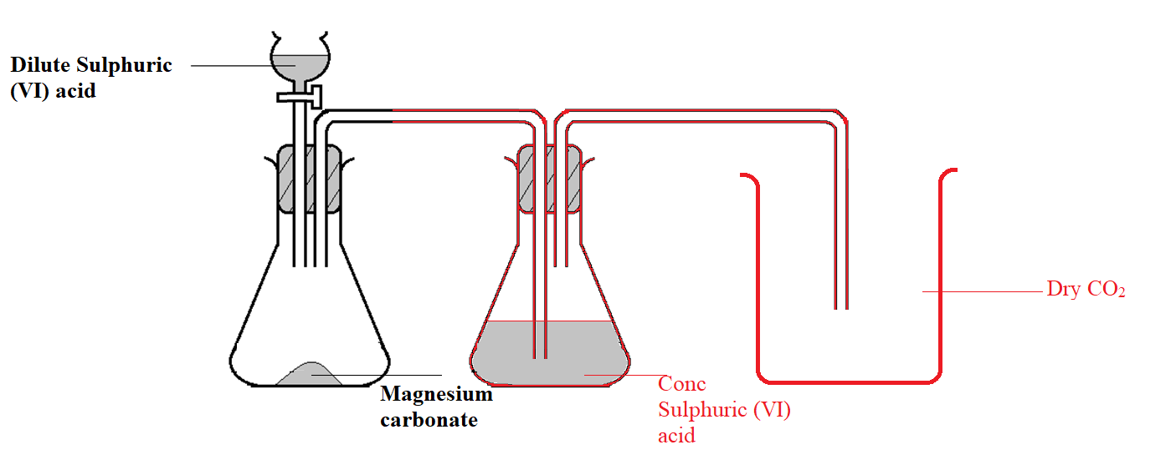
(ii) Write the equation for the reaction that took place in the conical flask (1mk)
MgCO_{3 (s)}+H₂SO_{4(aq)} MgSO_{4(aq)} +CO_{2(g)} +H₂O_{(l)}
(iii) Why is it not suitable to use the lead (ii) carbonate in place of magnesium carbonate in the set up (2mks)
PbCO₃ will react with H₂SO₄ to form insoluble PbSO₄ which coats it preventing any further reaction√1

(iv) State two properties of carbon (iv) oxide that makes it suitable for use in fire extinguishers. (1mk)
- Its denser than air hence prevents entry of O₂
- It doesn’t burn nor support combustion
(b) Carbon (iv) oxide gas reacts with red-hot carbon to produce a colourless gas P
i) Identify gas P (1mk)
Carbon (II) Oxide (CO)
ii) State one precaution to be taken while preparing gas P in the laboratory. Explain your answer. (2mks)
The experiment should be done in the fume chamber/open air – CO is a poisonous gas.
c) Study the flow chart below that represents the manufacture of sodium carbonate
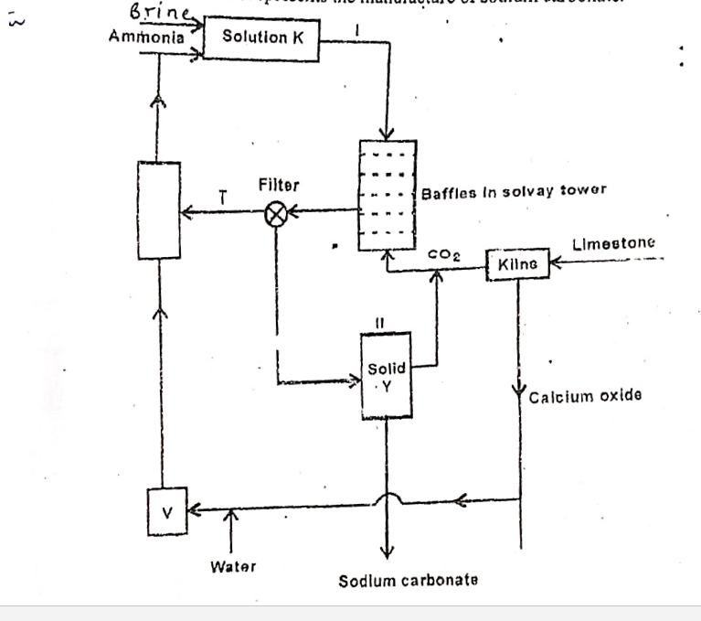
(i) Identify substances; (2mks)
K: Ammoniacal brine/ammoniated brine
T: Ammonium chloride
Y: Sodium hydrogen carbonate
V: Calcium hydroxide
ii) Write an equation for the reaction that takes place in the in the;
Lime kiln (1mk)
CaCO_{3(s)} ^{heat} CaO_{(s)} + CO_{2(g)}
Solvay tower (1mk)
NH_{3(g)} +H₂O_{(l)} + CO_{2(g)} + NaCl_{(aq)} → NaHCO_{3(aq)} + NH₄Cl_{(aq)}
Accept: i) NH₃+CO₂ +H₂O → NH₄HCO₃
ii) NH₄HCO₃ +NaCl → NaHCO₃ + NH₄Cl
7. The diagram below shows part of the periodic table. The letters do not represent the actual symbols of the elements .Use the diagram to answer the questions that follow.
 |  |  |  |  |  |  |  | Q
R |  |  |  |  | K | T
 | Z |  | N |  |  | V | W
Y |  |  |  |  |  |  | X

i) Compare the reactivity of W and X, explain (2mks)
W is more reactive than X, 1mk W has a shorter smaller atomic radius hence accepts an electron readily 1mk
ii) Give the formula of the compound formed between Z and W (1mk)
ZW₂/MgCl₂
iii) Element K is in group (v) and period 2 of the periodic table. Locate the position of the element in the grid above (1mk)
iv) How do the melting points of R and T compare. Explain (2mks)
R has higher M.P than T 1mk .R has a metallic bond ½ mk with giant metallic structures while T has simple molecular structure with weak Van der Waals forces ½ mk
v) Using dots (.) and crosses (x),show the bonding between K and hydrogen. (2mks)
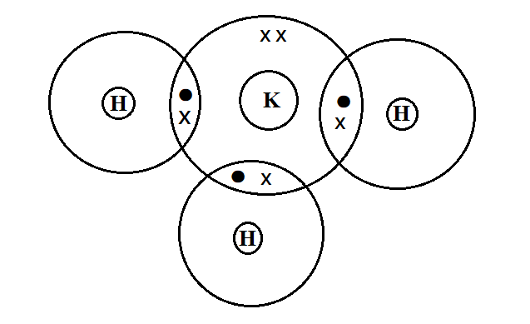
vi). Select an element that could be used : (2mks)
i). In weather balloons
Q
ii). For making cooking pots
N

